Business Hangouts
The BID Community Think Tank is using Business Hangouts, a collaboration platform built on Google+ Hangouts. Business Hangouts resolves some issues with Google+ Hangouts and adds a number of useful features, some of which are described below.

Requirements
The Business Hangouts application does not work under Internet Explorer nor is it supported on tablets (Android or iOS) due to limitations in the Google+ Hangouts platform. The preferred browsers are Chrome, Firefox and Safari.

Although Google+ Hangouts provides echo suppression, it is best to use earbuds or a headset so that the microphone does not pick up sound from the speakers. The alternative is to mute the microphone when not speaking.

Video requires both processing power and Internet bandwidth. Depending on your situation, you may need to close CPU-intensive applications or reduce the bandwidth usage using the Google+ Hangouts controls at the top of the screen.

Registration
One of the improvements over the Google+ platform is the ability to set up a registration page where participants can signup for the webinar using their Google+, LinkedIn or Facebook accounts (see Confirmation about differences between participants and viewers). 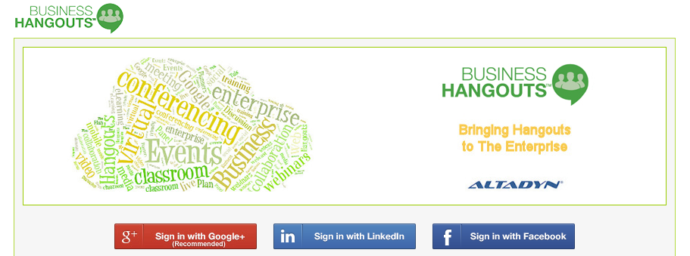

Google+ Hangouts on Air does not support the ability to connect via phone line at this time.

The registration process will obtain information from the Google+, LinkedIn or Facebook. If you have multiple Google+ accounts, ensure that you are logged into the right account before clicking on Sign in with Google+.

Confirmation
The webinar host will confirm your registration and determine if you will be a participant or a viewer. Business Hangouts support up to ten participants who can use the full audio and video conferencing capabilities. Due to limitations of the underlying Google+ platform, all participants must register with a Google+ or Gmail account. Viewers follow the webinar through a simplified version of the user interface as explained below and can raise questions or comments using the Unified Chat interface.

Registrants will receive a confirmation email with a link that needs to be used to enter the webinar. The email also contains a link that will add the event to your calendar. The Add to: Google updates your Google calendar directly. The Add to: Outlook downloads an ics/iCal file that should launch your default calendar application.

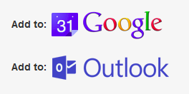

Participating in the Webinar
The webinar link in the confirmation email will be active 30 minutes before the scheduled webinar. You may be asked to confirm the e-mail address you used to register. However, the webinar will not be available until the host has started it.

Depending on your browser and the last time you used Business Hangouts, you may need to authorize Google+ access to various functions. You may see the following pop-up – click on the Close button. You will see the standard Google+ Hangouts page with the Business Hangouts application starting up. Once everything loads, you may be asked to agree with being recording and should see something like the following (viewers will not have the participant controls at the top and left borders).

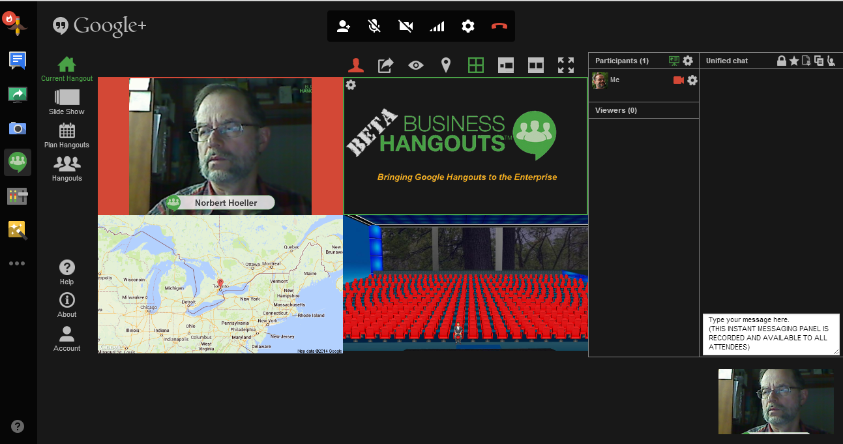

The key parts of the screen:
- Controls at the top that allow you to mute your microphone, turn off your camera, adjust your video quality/bandwidth usage, set you video/audio devices and hang up from the webinar.
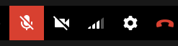
- The '4-quadrant' display showing the active broadcast feed (including any screenshows), a place to display shared content (images, YouTube videos), a map of where attendees are located and a simulated conference room showing how many people are attending.
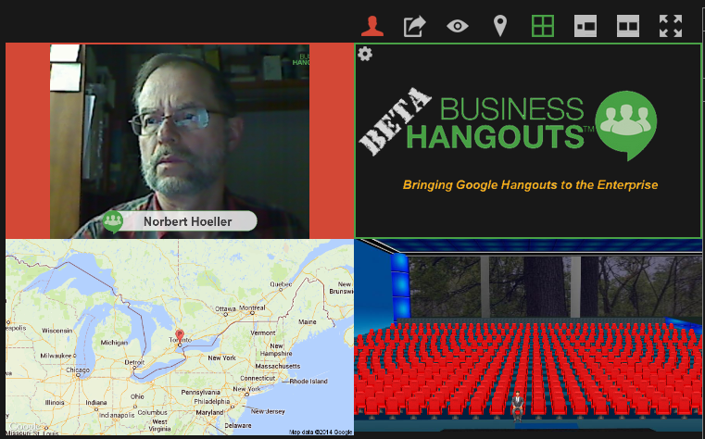
- Controls just above or to the right of the 4-quadrants allow you to increase the size of the display area (the webinar host can switch views between all 4-quadrants, location map, conference room, shared content and just the broadcast feed).
- To the right of the 4-quadrants is a list of the participants.
- On the far right is the Unified Chat window with a list of messages and an area at the bottom where you can type messages.
- At the far left are standard Google+ Hangouts applications - the most useful ones are Screenshare and Business Hangouts which allows you to restart the application if you get bumped out.
- At the bottom is a filmstrip of the participants.

Going ‘Live’
The webinar host determines when the webinar ‘goes live’. Prior to this time, viewers will not see anything in the upper-left box of the 4-quadrants although the Unified Chat will be active. Participants have an opportunity to check out their video and audio feeds. It is a good idea to check the ‘gear’ icon in the Google+ controls at the top to verify that you are using the correct audio devices. To test audio, look for a green ‘volume indicator’ in the lower right corner of your filmstrip image while speaking.

Once the webinar is being broadcast, YouTube will broadcast the feed to Participants and Viewers and also automatically record the session. This recording will be made available via the B3D YouTube channel shortly after the webinar finishes.

Participant Hints and Tips
Your video feed is only as good as your camera. Good lighting and a clean background also help. Although Google+ Hangouts recently announced better support for backlighting, lighting from the front reduces shadows.

In presentation mode, the webinar host controls who is ‘on air’. In conference mode, Business Hangouts will display the speaker in the upper-left quadrant but sometimes switches if the application ‘hears’ activity from one of the other participants. It is best to mute your microphone if you are not speaking.

The Google+ Hangouts controls at the top of the screen sometimes ‘roll up’ out of sight. Sometimes maximizing your browser window helps. If not, go into fullscreen mode (F11 on Windows, fullscreen option on browser menu of Macs).

Viewer Hints and Tips
The live stream is displayed via YouTube. There is typically a 45-60 second delay in the YouTube stream. Clicking on the YouTube screen element pauses the stream in case you have to step away for a minute. Clicking again restarts the stream from where you left off.

